**Lab – 44: How to use Fresh Start to reset Windows 10 devices with Intune?**

**Objective:** The objective of this lab is –

* To use Fresh start to reset Windows 10 devices with Intune.

The Fresh Start device action removes any apps that were installed on a Windows 10 PC running the Creators Update, then automatically updates the PC to the latest version of Windows. This can be used to help remove pre-installed (OEM) apps that are often delivered with a new PC. You can configure if user data is retained when this device action is issued. In this case, apps and settings are removed, but the contents of the users Home folder are retained. This action will basically reset your Windows 10 device. So, in this lab we’ll see how you can use fresh start to reset Windows 10 devices with Microsoft Intune.

**Prerequisite:** EMS Enterprise Mobility + Security E5.

**Steps:**

1. Sign in to your Azure Portal, by using the link - **https://portal.azure.com/**. Enter your credentials and click Sign In.

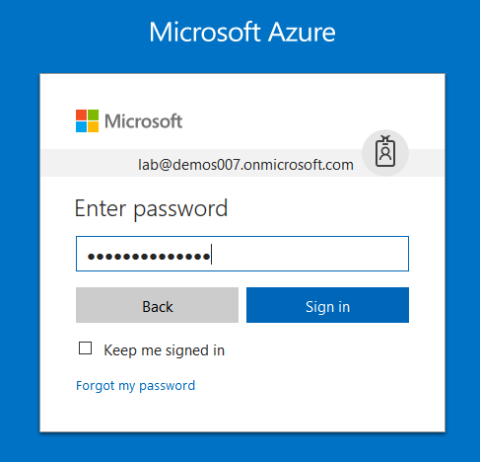

1. Microsoft Azure AD Dashboard will open.

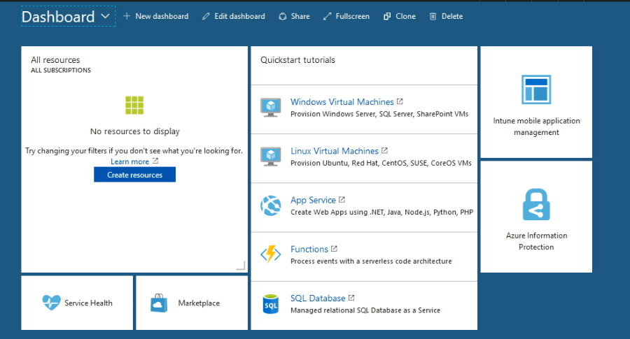

1. Open **Microsoft Intune** service from the left-hand side of the Azure portal.
2. Once you've opened the **Microsoft Intune** blade, select **Devices**.

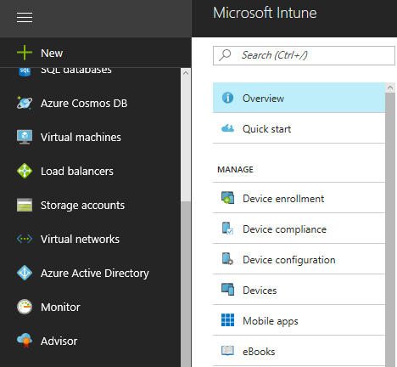

1. On the **Devices and groups** blade, choose **All devices**.

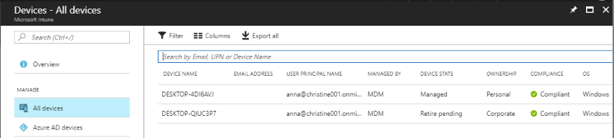

1. From the list of devices, you manage, choose a device.
2. Then a device details will be shown in the **Overview** blade. Select **…More** option from top right corner. And, select **Fresh Start** device remote action. So, you can remotely fresh start your device.

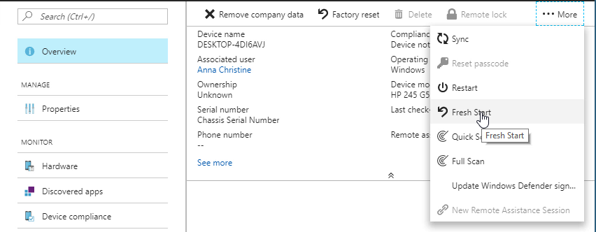

1. When you click **Fresh Start**. Your fresh start request for this device will be created and this device will start to reset.
2. It will take time to reset the device as per your apps and configuration. After reset your device will be cleaned and it will remove all your pre-installed apps and configuration settings.
3. So, in this way you can remotely fresh start your Windows 10 device with Intune.